**C# Arrays**

In this tutorial, we will learn about C# arrays. We will learn to create, initialize, and access array with the help of examples.

An array is a collection of similar types of data. For example,

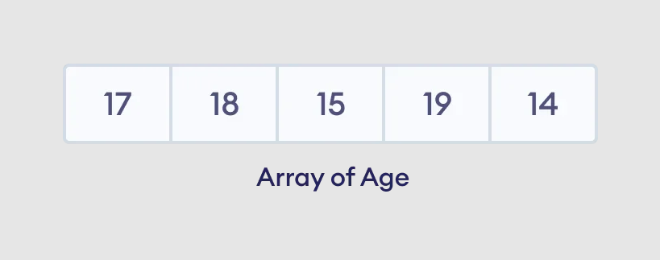Suppose we need to record the age of 5 students. Instead of creating 5 separate variables, we can simply create an array:

Elements of an Array

**1. C# Array Declaration**

In C#, here is how we can declare an array.

datatype[] arrayName;

Here,

* dataType - data type like int, string, char, etc
* arrayName - it is an identifier

Let's see an example,

int[] age;

Here, we have created an array named age. It can store elements of int type.

**But how many elements can it store?**

To define the number of elements that an array can hold, we have to allocate memory for the array in C#. For example,

// declare an array

int[] age;

// allocate memory for array

age = new int[5];

Here, new int[5] represents that the array can store 5 elements. We can also say the size/length of the array is 5.

**Note**: We can also declare and allocate the memory of an array in a single line. For example,

int[] age = new int[5];

**2. Array initialization in C#**

In C#, we can initialize an array during the declaration. For example,

int [] numbers = {1, 2, 3, 4, 5};

Here, we have created an array named numbers and initialized it with values **1**, **2**, **3**, **4**, and **5** inside the curly braces.

Note that we have not provided the size of the array. In this case, the C# automatically specifies the size by counting the number of elements in the array (i.e. 5).

In an array, we use an **index number** to determine the position of each array element. We can use the index number to initialize an array in C#. For example,

// declare an array

int[] age = new int[5];

//initializing array

age[0] = 12;

age[1] = 4;

age[2] = 5;

...

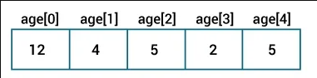

C# Array Initialization

**Note**:

* An array index always starts at 0. That is, the first element of an array is at index 0.
* If the size of an array is 5, the index of the last element will be at 4 (5 - 1).

**3. Access Array Elements**

We can access the elements in the array using the index of the array. For example,

// access element at index 2

array[2];

// access element at index 4

array[4];

Here,

* array[2] - access the 3rd element
* array[4] - access the 5th element

**Example: C# Array**

using System;

namespace AccessArray {

class Program {

static void Main(string[] args) {

// create an array

int[] numbers = {1, 2, 3};

//access first element

Console.WriteLine("Element in first index : " + numbers[0]);

//access second element

Console.WriteLine("Element in second index : " + numbers[1]);

//access third element

Console.WriteLine("Element in third index : " + numbers[2]);

Console.ReadLine();

}

}

}

**Output**

Element in first index : 1

Element in second index : 2

Element in third index : 3

In the above example, we have created an array named numbers with elements **1, 2, 3**. Here, we are using the **index number** to access elements of the array.

* numbers[0] - access first element, **1**
* numbers[1] - access second element, **2**
* numbers[3] - access third element, **3**

**4. Change Array Elements**

We can also change the elements of an array. To change the element, we simply assign a new value to that particular index. For example,

using System;

namespace ChangeArray {

class Program {

static void Main(string[] args) {

// create an array

int[] numbers = {1, 2, 3};

Console.WriteLine("Old Value at index 0: " + numbers[0]);

// change the value at index 0

numbers[0] = 11;

//print new value

Console.WriteLine("New Value at index 0: " + numbers[0]);

Console.ReadLine();

}

}

}

**Output**

Old Value at index 0: 1

New Value at index 0: 11

In the above example, the initial value at index 0 is 1. Notice the line,

//change the value at index 0

numbers[0] = 11;

Here, we are assigning a new value of **11** to the index 0. Now, the value at index 0 is changed from **1** to **11**.

**5. Iterating C# Array using Loops**

In C#, we can use loops to iterate through each element of an array. For example,

**Example: Using for loop**

using System;

namespace AccessArrayFor {

class Program {

static void Main(string[] args) {

int[] numbers = {1, 2, 3};

for(int i=0; i < numbers.Length; i++) {

Console.WriteLine("Element in index " + i + ": " + numbers[i]);

}

Console.ReadLine();

}

}

}

**Output**

Element in index 0: 1

Element in index 1: 2

Element in index 2: 3

In the above example, we have used a [for loop](https://www.programiz.com/csharp-programming/for-loop) to iterate through the elements of the array, numbers. Notice the line,

numbers.Length

Here, the Length property of the array gives the size of the array.

We can also use a [foreach loop](https://www.programiz.com/csharp-programming/foreach-loop) to iterate through the elements of an array. For example,

**Example: Using foreach loop**

using System;

namespace AccessArrayForeach {

class Program {

static void Main(string[] args) {

int[] numbers = {1, 2, 3};

Console.WriteLine("Array Elements: ");

foreach(int num in numbers) {

Console.WriteLine(num);

}

Console.ReadLine();

}

}

}

**Output**

Array Elements:

1

2

3

**6. C# Array Operations using System.Linq**

In C#, we have the System.Linq namespace that provides different methods to perform various operations in an array. For example,

**Example: Find Minimum and Maximum Element**

using System;

// provides us various methods to use in an array

using System.Linq;

namespace ArrayMinMax {

class Program {

static void Main(string[] args) {

int[] numbers = {51, 1, 3, 4, 98};

// get the minimum element

Console.WriteLine("Smallest Element: " + numbers.Min());

// Max() returns the largest number in array

Console.WriteLine("Largest Element: " + numbers.Max());

Console.ReadLine();

}

}

}

**Output**

Smallest Element: 1

Largest Element: 98

In the above example,

* numbers.Min() - returns the smallest number in an array, **1**
* numbers.Max() - returns the largest number in an array, **98**

**Example: Find the Average of an Array**

using System;

// provides us various methods to use in an array

using System.Linq;

namespace ArrayFunction {

class Program {

static void Main(string[] args) {

int[] numbers = {30, 31, 94, 86, 55};

// get the sum of all array elements

float sum = numbers.Sum();

// get the total number of elements present in the array

int count = numbers.Count();

float average = sum/count;

Console.WriteLine("Average : " + average);

// compute the average

Console.WriteLine("Average using Average() : " + numbers.Average());

Console.ReadLine();

}

}

}

**Output**

Average : 59.2

Average using Average() : 59.2

In the above example, we have used

* numbers.Sum() to get the sum of all the elements of the array
* numbers.Count() to get the total number of element present inside the array

We then divide the sum by count to get the average.

float average = sum / count;

Here, we have also used the numbers.Average() method of the System.Linq namespace to get the average directly.

**Note**: It is compulsory to use the System.Linq namespace while using Min(), Max(), Sum(), Count(), and Average() methods.